Protocol for Treating Chronic Pelvic Pain Syndrome (CPPS) / Chronic Prostatitis (CP)
Using Low-Intensity Shockwaves
Device: MoreNova - C30 Large area coverage Probe
Document Version: 1.0
Date: 20/11/24
1. Purpose and Scope
This protocol provides a standardized treatment plan for using low-intensity shockwaves to
manage Chronic Pelvic Pain Syndrome (CPPS) or Chronic Prostatitis (CP). It is intended for
healthcare providers using the MoreNova Device with the C30 Probe to target the prostatic,
pelvic floor, and perineal regions. This protocol applies to men aged 18–80 years diagnosed
with CPPS or CP, especially those who have not responded to antibiotic treatments. For
further information on clinical studies and efficacy, visit our Clinical Data Center.
Device Overview:
MoreNova is a portable Electromagnetic (EM) Low-Intensity Shockwave (LISW) device
designed to reduce inflammation, dissolve calcifications, and stimulate angiogenesis,
improving outcomes for various conditions in men and women.
2. Introduction
Chronic pelvic pain (CPP) is a debilitating condition that affects the quality of life, presenting
as persistent or recurring pain in the pelvic region. Chronic Prostatitis/Chronic Pelvic Pain
Syndrome (CP/CPPS) is often abacterial in nature and is characterized by symptoms such as
genitourinary pain, lower urinary tract symptoms (LUTS), and sexual dysfunction.
Low-Intensity Extracorporeal Shockwave Therapy (LiESWT) provides a non-invasive
treatment option that improves pelvic circulation, reduces myofascial pain, and enhances
nerve function in the affected regions.
3. Scientific Review
Current Treatments:
•
Drug therapy: Medications like alpha-blockers (e.g., tamsulosin) are commonly
used but often insufficient.


•
•
Physical therapy: Focused on myofascial trigger points but may not address deeper
issues effectively.
Antibiotics: Often ineffective for abacterial prostatitis.
Advantages of LiESWT:
•
•
•
Non-invasive, painless treatment with no known significant complications.
Targets deeper urogenital structures and myofascial trigger points.
Promotes angiogenesis, improves tissue oxygenation, and reduces pelvic floor
tension.
4. Patient Selection Criteria
Inclusion Criteria:
1
2
.
.
Diagnosis of CPPS/CP, with symptoms persisting for at least 3 months in the last 6
months.
Age 20–70 years.
Exclusion Criteria:
1
2
3
4
5
6
.
.
.
.
.
.
History of prostate, bladder, or urethral cancer.
History of pelvic radiation or systemic chemotherapy.
Prostate surgery or presence of penile/urinary sphincter implants.
Active urethral structure, bladder stones, or lower urinary tract infections.
Neurological impairment or psychiatric disorders.
Presence of a device sensitive to electromagnetic radiation (e.g., pacemaker).
5. Pre-Treatment Screening
To determine the patient's suitability for LiESWT, conduct the following:
•
•
Comprehensive medical history review.
Physical examination, including digital rectal exam (DRE) and palpation of the pelvic
floor.
•
•
Imaging: Use ultrasound to measure residual urine volume and assess pelvic
structures.
Diagnostic questionnaires: NIH Chronic Prostatitis Symptom Index (NIH-CPSI) and
IPSS to evaluate pain and symptoms.

6. Treatment Protocol
Preparation:
•
•
Conduct a thorough medical history and physical examination.
Counsel the patient about the procedure, benefits, risks, and expected outcomes.
Procedure:
•
•
•
•
•
Number of Sessions: 6–10 sessions based on symptom severity.
Session Frequency: Twice per week.
Session Duration: 20 minutes.
Applications Per Session: 2 (targeting each side of the perineum).
Shocks Per Application: 1,500 (3,000 total shocks per session).
Treatment Parameters:
•
•
Energy (HV) Settings: 2.0 kV.
Frequency (FRQ): 2.5 Hz.
Post-Treatment Care:
•
•
Advise patients to avoid strenuous physical activity for 24 hours after each session.
Continue prescribed medications if applicable (e.g., alpha-blockers).
7. Treatment Areas and Techniques
The treatment focuses on the following anatomical areas:
•
•
•
Prostatic region.
Pelvic floor muscles.
Perineal region.
Probe Placement:
•
Position the probe over the perineal region, targeting the left and right sides
alternately.
•
•
Apply gentle pressure with ultrasound gel for optimal shockwave transmission.
Administer 1,500 shocks to each side.
8. Patient Comfort and Safety
To ensure patient comfort and safety during the procedure:

•
•
•
Position the patient supine or in a lithotomy position for optimal access.
Use ultrasound gel to minimize discomfort and enhance shockwave delivery.
Monitor patient feedback during the session and adjust settings if necessary.
9. Treatment Outcomes and Follow-Up
Expected Results:
•
•
Reduction in pain and discomfort after 3–6 weeks of treatment.
Improvement in NIH-CPSI and IPSS scores.
Follow-Up Visits:
•
•
Schedule follow-ups at 4 weeks and 12 weeks post-treatment.
Assess pain levels using the Visual Analog Scale (VAS) and other symptom scores.
10. Visuals and Diagrams
C30
•
Anatomical areas targeted (prostate, pelvic floor, perineum).
11. Quality Control
Device Calibration:
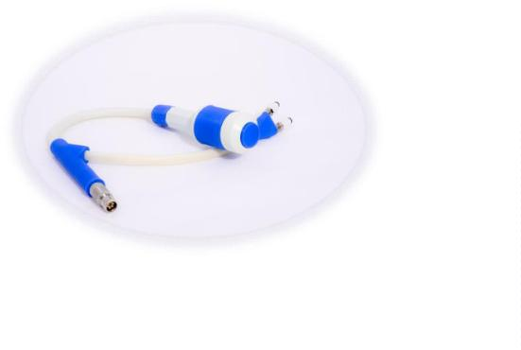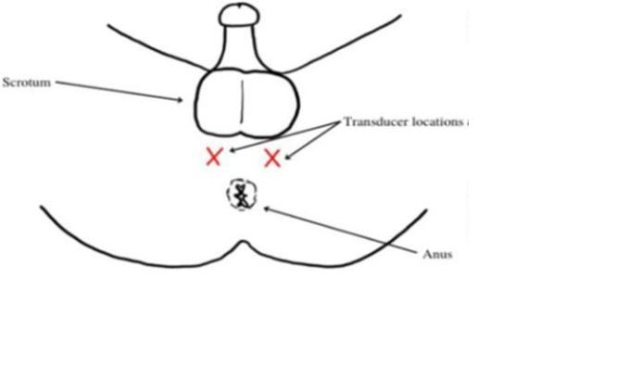

•
•
Verify device settings before each session.
The MoreNova Device recognizes preprogrammed parameters to ensure accuracy.
Clinician Training:
•
•
Ensure all operators are trained in the use of the MoreNova Device and C30 Probe.
Clinicians should be familiar with this protocol and the "Instructions for Use"
provided by the manufacturer.
Checklist for Each Session:
•
•
•
Confirm that the patient meets inclusion criteria and has no contraindications.
Ensure the device and probe are clean, sanitized, and functioning correctly.
Verify that probe placement aligns with specified anatomical areas.
12. References
For clinical studies and additional resources, visit the DirexGroup Clinical Data Center.

